INFO 101
Fisher
Summer 2016
Google Search Log

This search log is designed to help you keep track of your searches and your results.

This is a great strategy to use in future research projects. As you’re searching, you should keep track of the different key words and search terms you use. You should also pay attention to where you’re searching. When you need help, your professor (and your librarian!) will ask you where you’ve searched and which words you’ve used.

Part 1. Let’s start with Google.

1a. In the chart below, fill out the columns with at least three different searches. Try using different combinations of key words and search terms.

**IMPORTANT**
Be sure to take a screen shot of each search attempt and your results. Save these screenshots in a separate document.

Key Words & Search Terms  Just paste in EXACTLY what you typed in the search box | # of Results | Link to most helpful/relevant result

1b. Of your three results of above, which search worked the best and why?

1c. Which result looks most helpful to you? Why?

Part 2. Google Limiters
Let’s try using some Google limiters to narrow your results to different types of sites.

**IMPORTANT**
Be sure to take a screen shot of each search attempt and your results. Save these screenshots in a separate document.

2a. Try a Google search, but add site:.gov to the end of your search. Here’s an example:

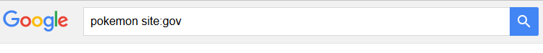

What happens when you add site:.gov to the end of your search? Type your answer below.

2b. Try a Google search, but add site:.edu to the end of your search. Here’s an example.

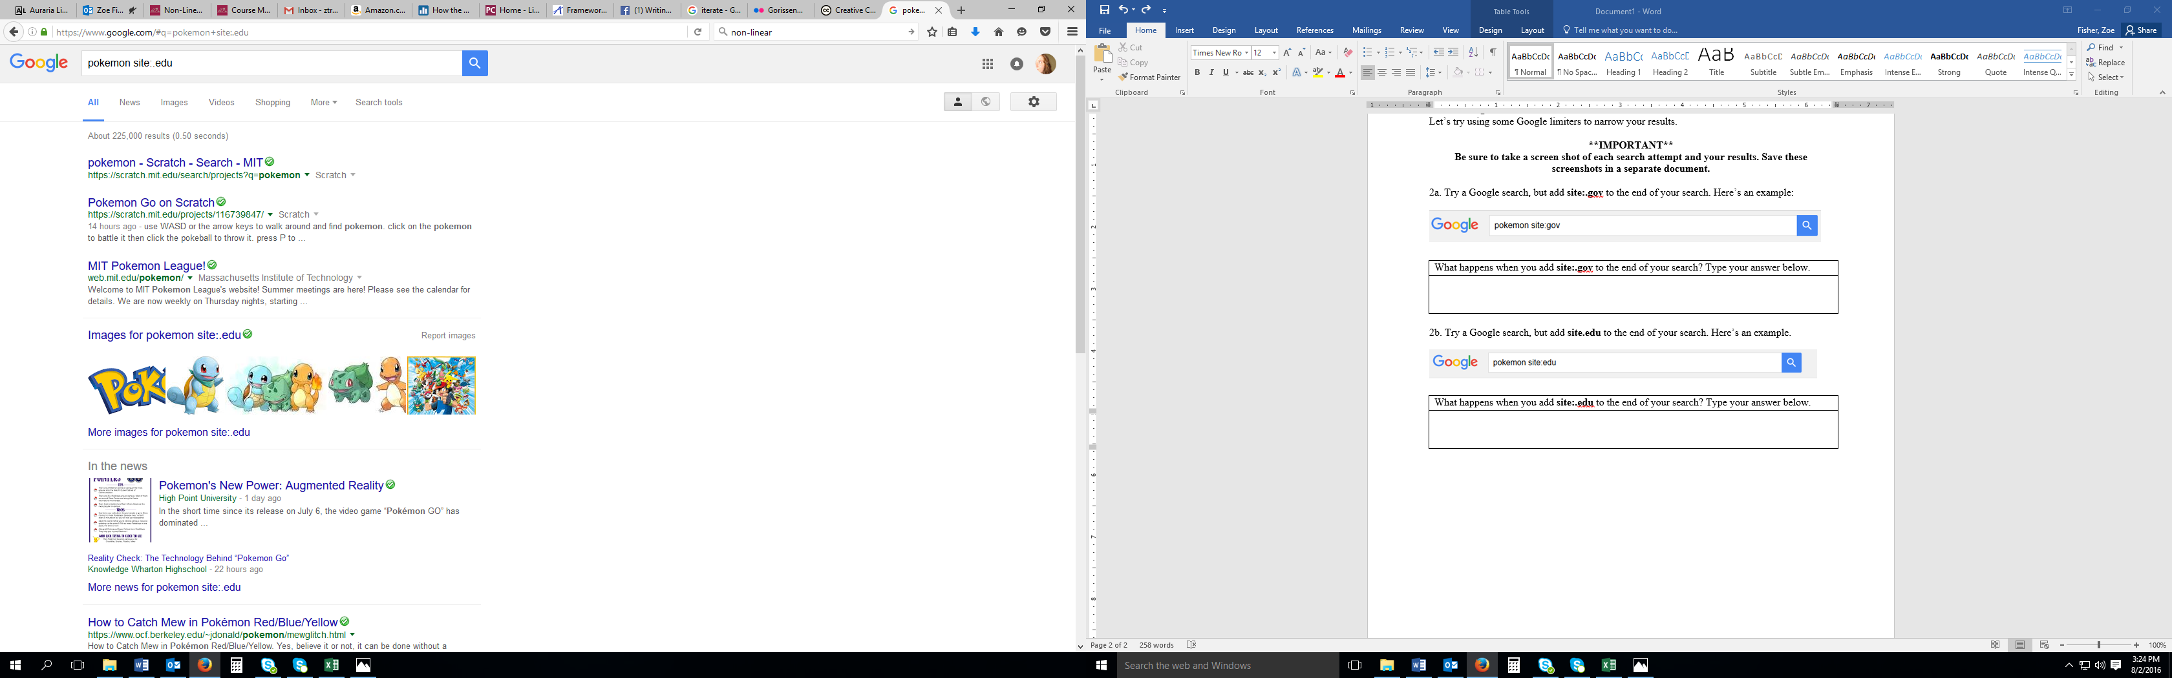

What happens when you add site:.edu to the end of your search? Type your answer below.

2c. Try a Google search, but add site:.org to the end of your search. Here’s an example:

What happens when you add site:.org to the end of your search? Type your answer below.

Part 3. Google Advanced Search
Go to https://www.google.com/advanced_search

3a. What are some of the options/features on the Advanced Search page?

3b. Why do you think Google hides/minimizes its Advanced Search page? (For example, there’s no link to Advanced Search on its homepage.)

